**Beet Seed**

Environment:

Windows 10 Home x64 bits; Laptop Asus VivoBook; Google Chrome Version 115.0.5790.171

Bug 1:

On the “Donation” web page (<https://philanthropy.mayoclinic.org/donateMC>) the phone number field and zip code field can receive letters as input without an error message being shown

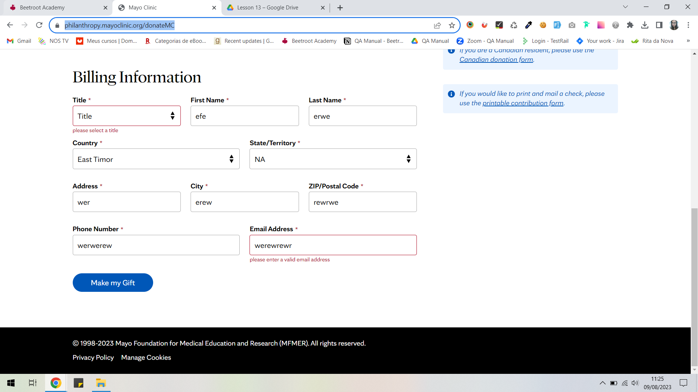

Bug 2:

On the “Create Your Account” Page (<https://signup.mayoclinic.org/?ApplicationID=24e83c70-19b1-4a2f-9412-fd5838c56be7>), the logo on top of the page is not clickable

Bug 3:

On the “Find a Doctor” (<https://www.mayoclinic.org/appointments/find-a-doctor>) page and on the “Terms and Conditions” page (<https://www.mayoclinic.org/about-this-site/terms-conditions-use-policy>) the company’s logo on the top banner has a problem and it’s not shown

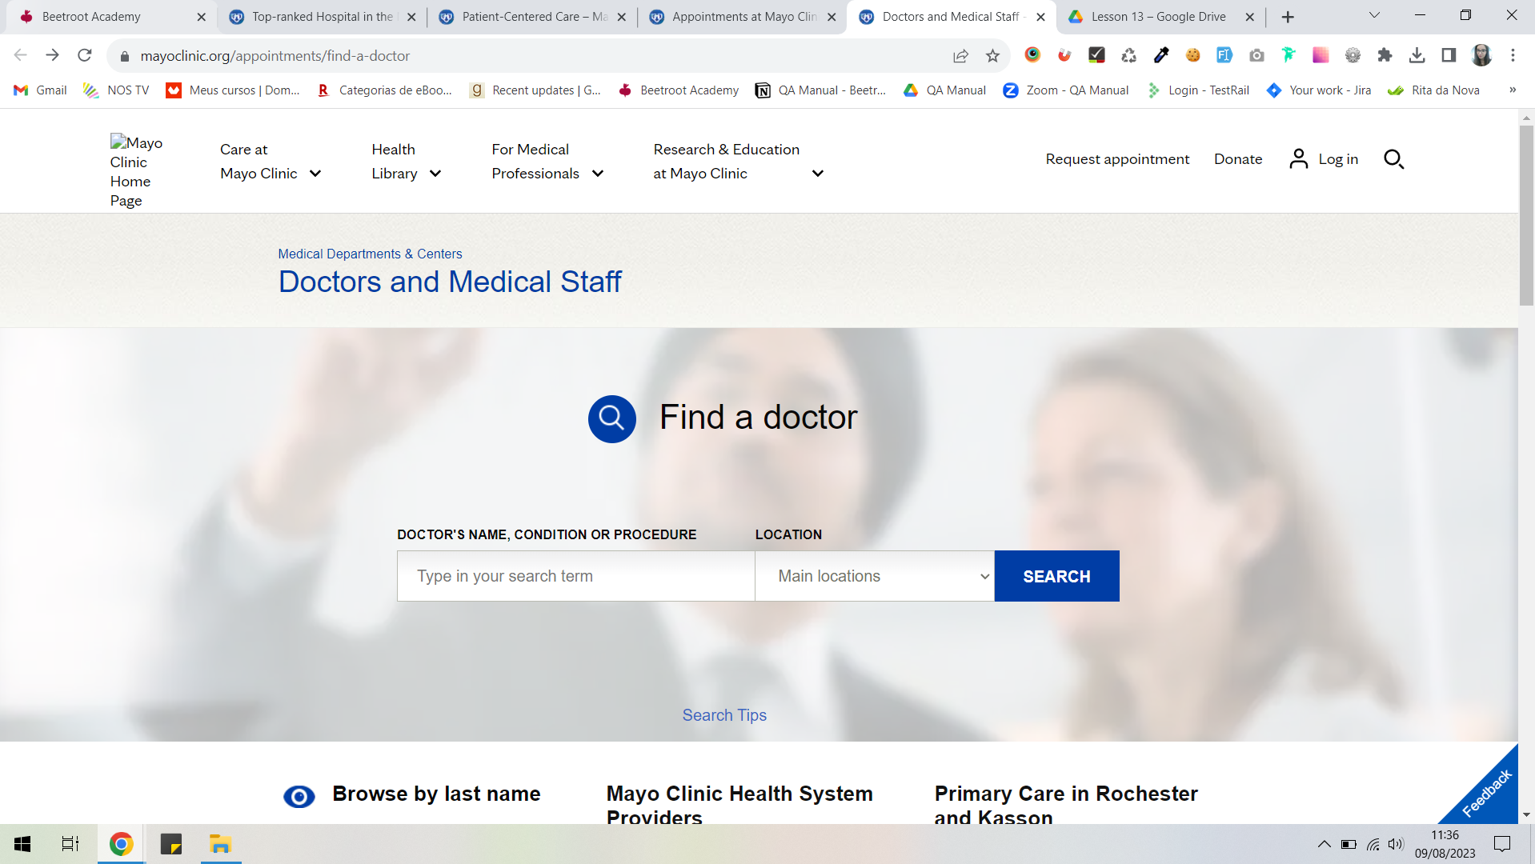

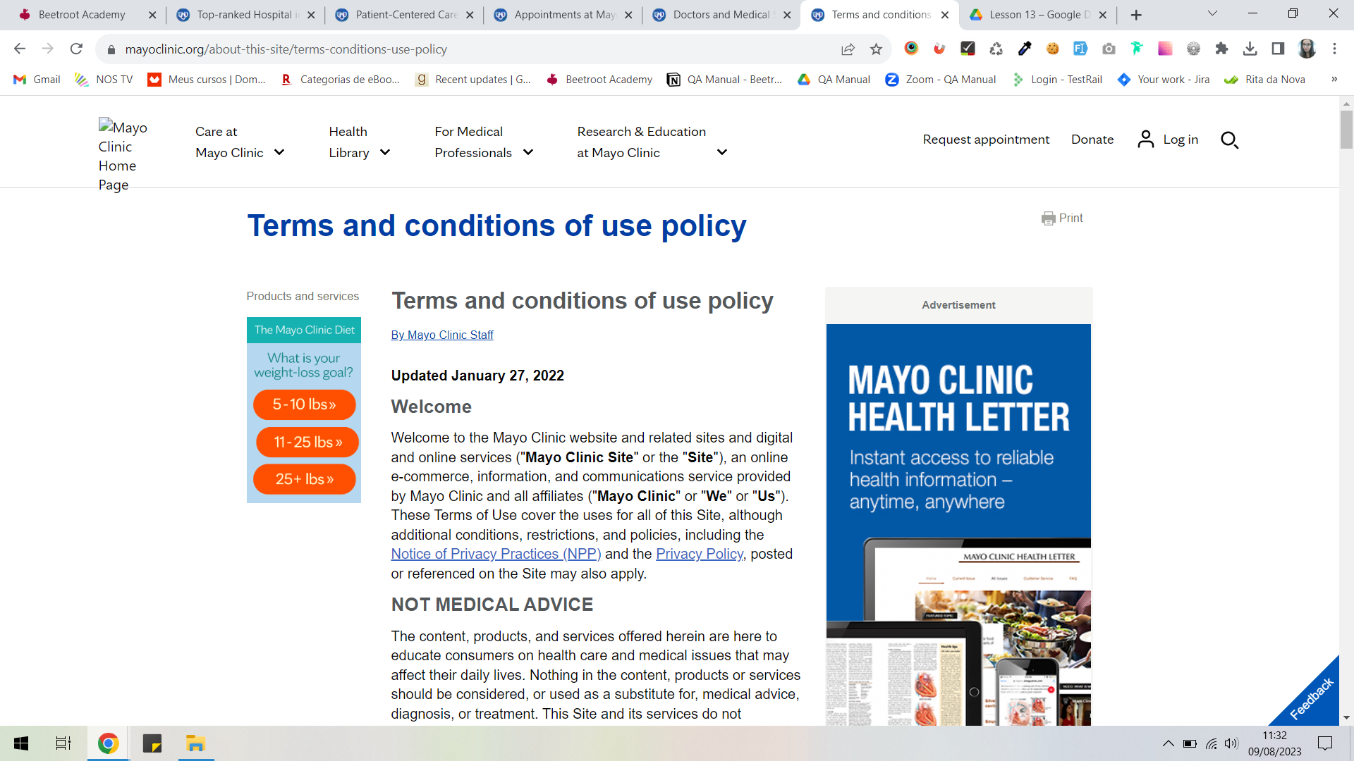

Bug 4:

On the “Symptoms” page (<https://www.mayoclinic.org/symptoms>) on the First Aid column, the “Try our voice app” doesn’t work: it can be clicked but nothing happens - another tab is not open nor is the user redirected to a different page

Bug 5:

On the “Contact Mayo Clinic” page (<https://www.mayoclinic.org/about-mayo-clinic/contact>) some of the images in the section “Other Topics in Care at Mayo Clinic” are cut and don’t have the same size.

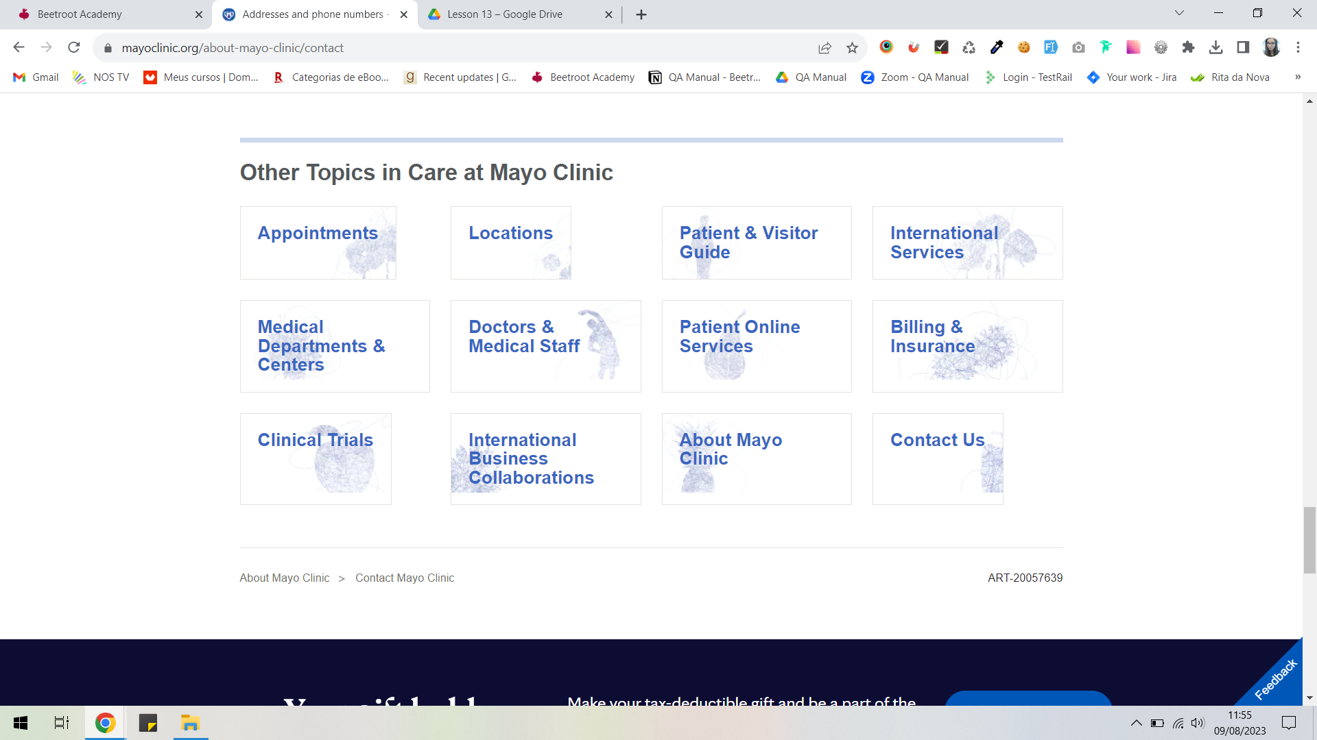

**Beet Sprout**

Used Browsers:

* Mozila Firefox version 116.0.2
* Opera One version 101.0.4843.33
* Microsoft Edge version 115.0.1901.188

Bug 1:

The bug also occurs on the tested browsers:

Microsoft Edge

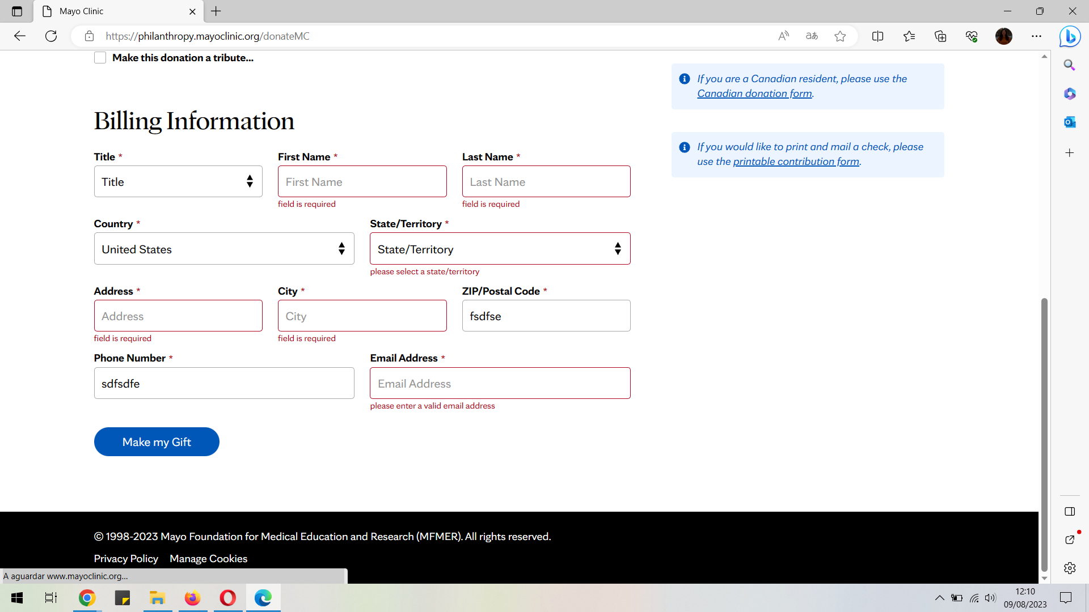

Mozilla Firefox

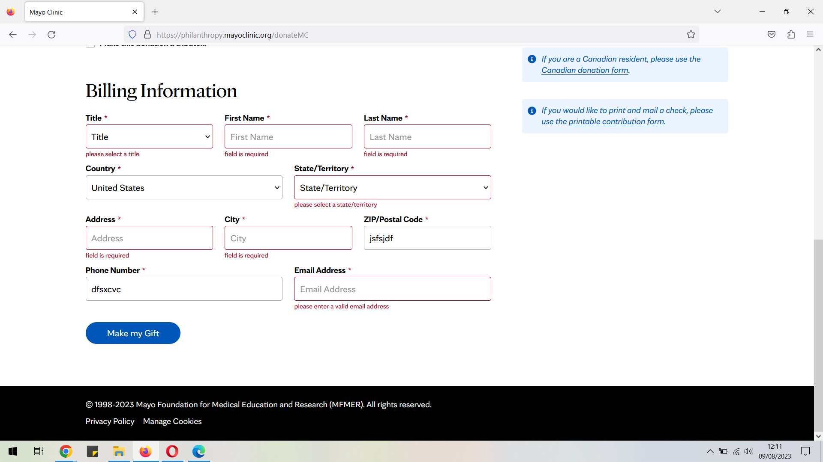

Opera One

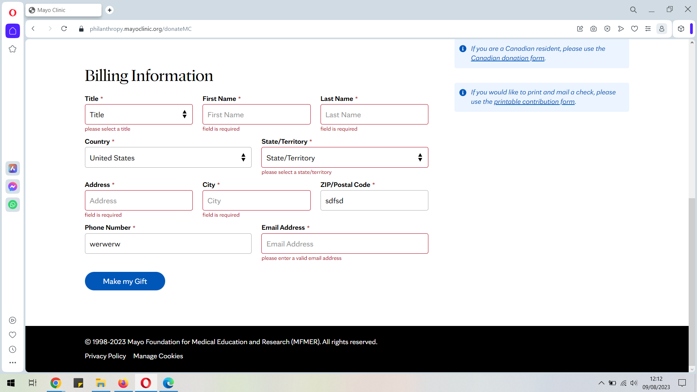

Bug 2: On the tested browsers the logo is still not clickable on the “Create Your Account” page (<https://signup.mayoclinic.org/?ApplicationID=24e83c70-19b1-4a2f-9412-fd5838c56be7>)

Bug 3: On the Microsoft Edge and Opera One the pages appear as on Google Chrome, with an error next to the “Mayo Clinic Home Page” on the top where the logo should be.

On Mozila Firefox the error icon doesn’t appear on either page neither the logo.

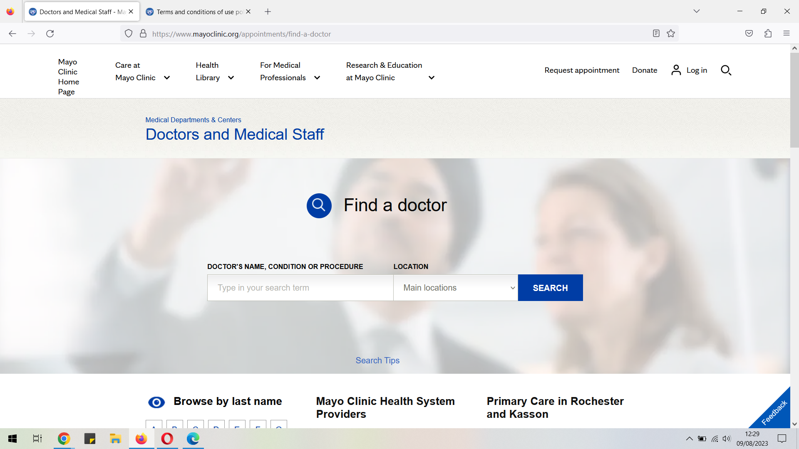

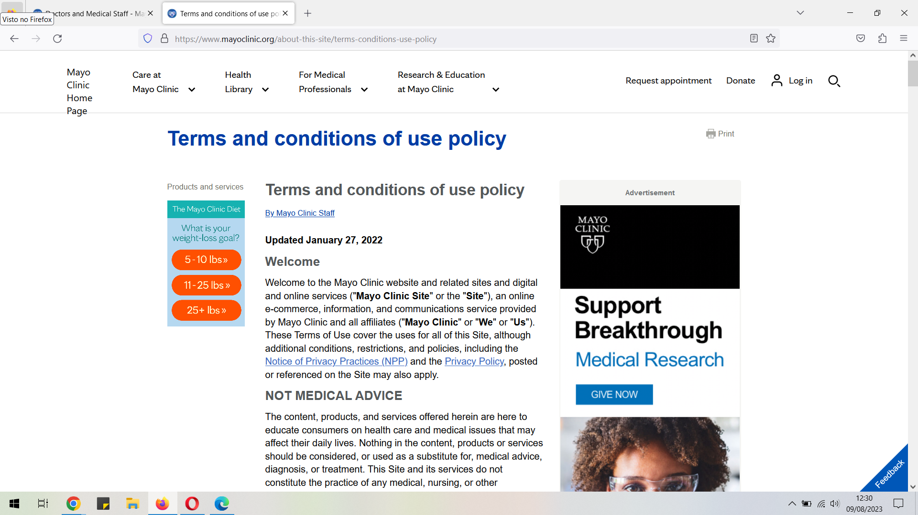

Bug 4: On Microsoft Edge the button appears and its possible to click it but nothing happens, as in Google Chrome.

In Firefox, the button and information about the voice app is not shown

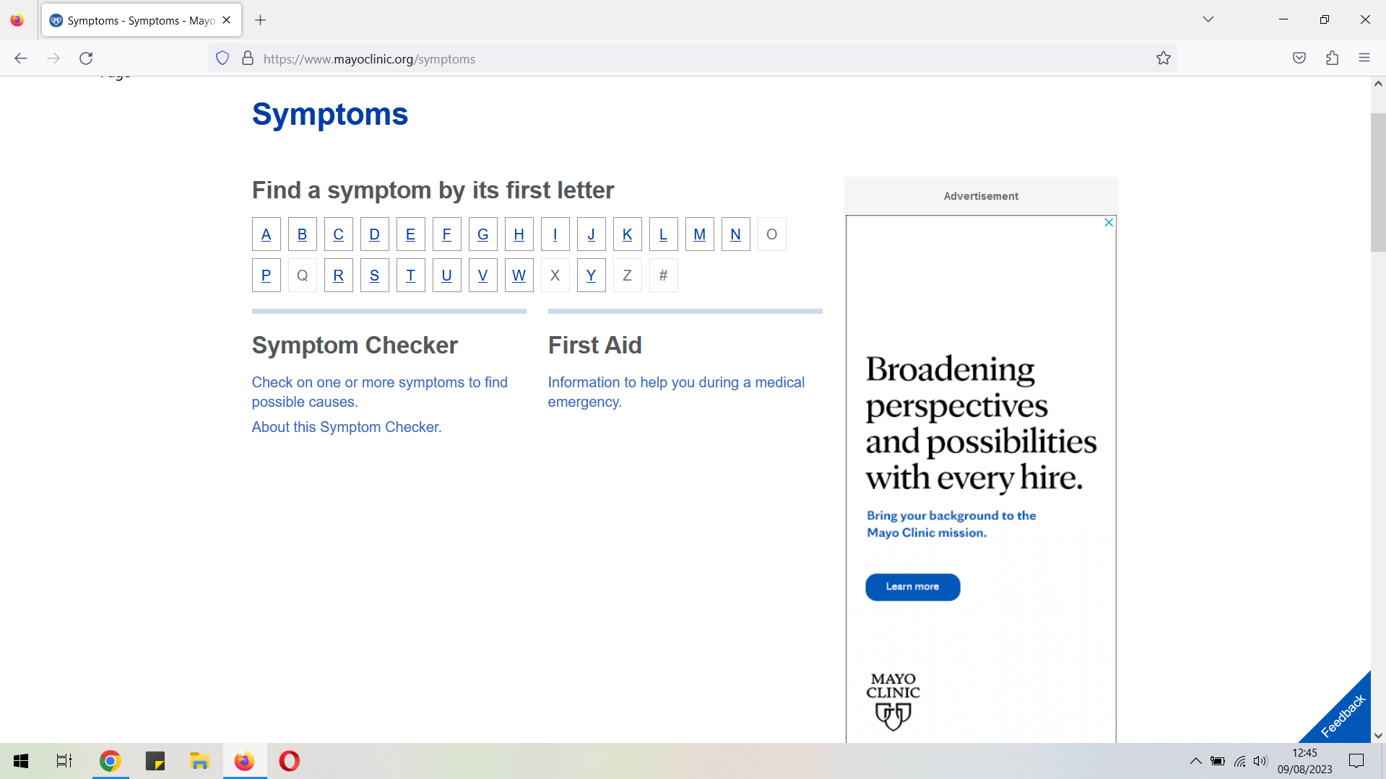

The same happens on Opera One

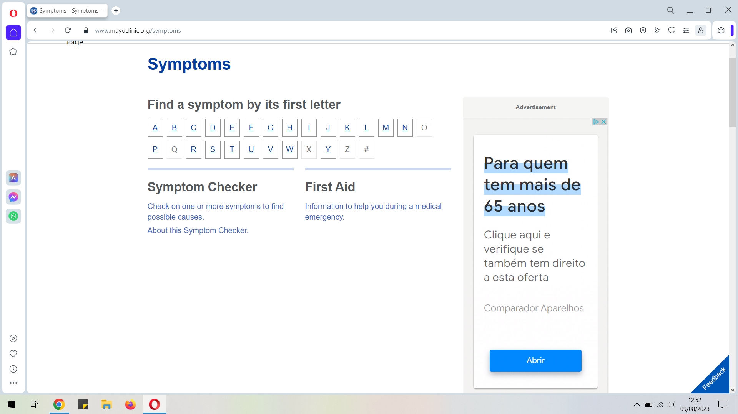

Bug 5: On the three browsers some of the pictures still appear cut and a different size from the others, as in Google Chrome

Microsoft Edge

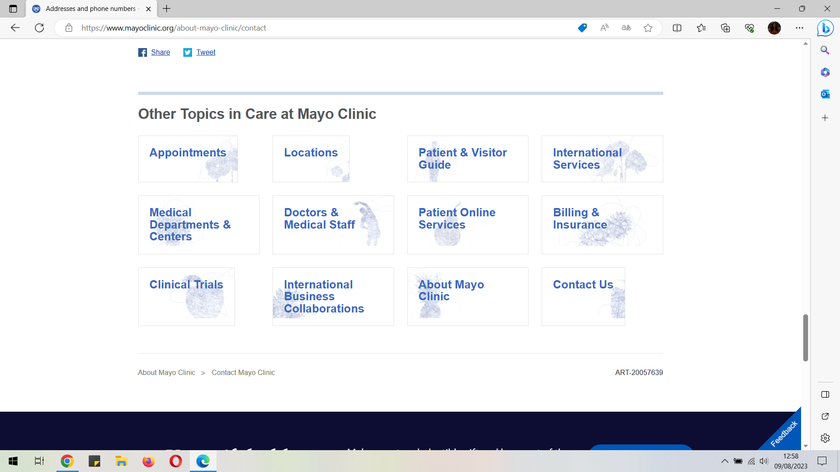

Mozila Firefox

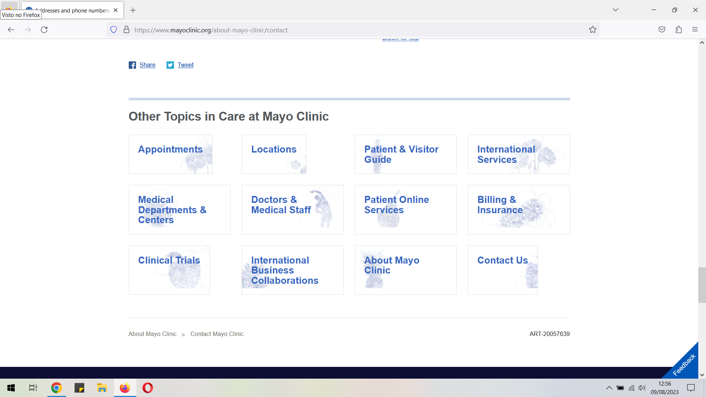

Opera One

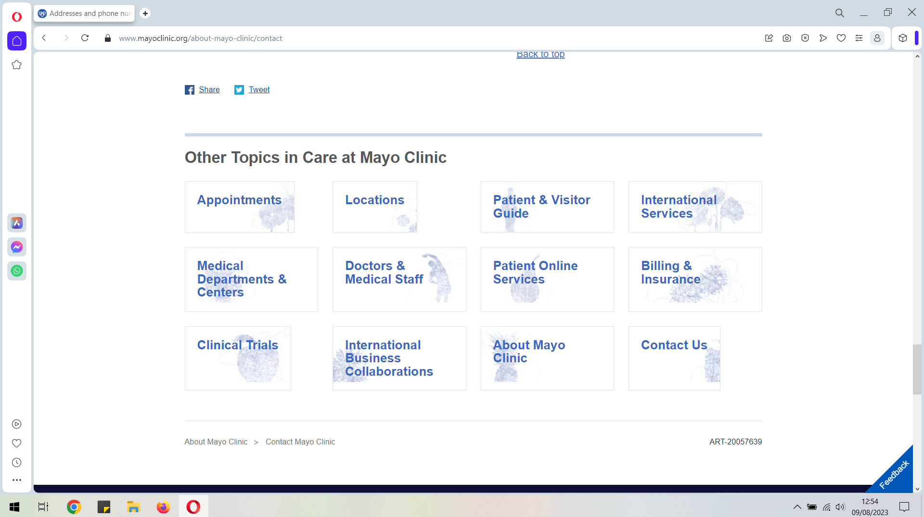

**Mighty Beet**

* ‘Log in to Patient Account’ in the header
  + font: system-ui
  + font size: 20 px
  + color: rgb(8, 8, 8)
  + background color:
* ‘Learn more about Mayo Clinic’ button - could find it
  + font
  + font size
  + color
  + background color
* feedback rate buttons (numbers from 1 to 5, presented within feedback form which can be called by click on Feedback button (bottom-right corner))
  + font: Helvetica
  + font size: 14px
  + color: rgb(64, 64, 74)
  + background color: #f7f7f8
* Language labels for language change
  + font:system-ui
  + font size: 20px
  + color: rgb(8, 8, 8)
  + background color: #012d61;